Script-Controlled ACL – Restrict Record Access Based on Field Value

Project Documentation Phase:
- Introduction
The Project Documentation Phase is an important stage in the development of the project “Script-Controlled ACL – Restrict Record Access Based on Field Value.” Documentation provides a complete record of the project requirements, design, implementation, testing, and results.
The main purpose of this phase is to explain how the Script-Controlled ACL was created and how it controls access to records based on a particular field value. Proper documentation also helps developers and administrators understand, maintain, troubleshoot, and modify the ACL in the future.
- Project Objective
The main objective of this project is to restrict access to ServiceNow records based on the value stored in a particular field.
The system checks whether the user satisfies the required condition. If the condition is satisfied, the user is allowed to access the record. If the condition is not satisfied, access is restricted.
Main objectives are:
- To improve record-level security.
- To prevent unauthorized access to records.
- To implement dynamic access control.
- To use scripting for complex security requirements.
- To control access based on field values.
- To provide better protection for sensitive information.
- To make the access-control process more flexible.

- Problem Statement
In a ServiceNow environment, different users may have access to the same table. However, every user may not be authorized to view every record in that table.
For example, consider an organization where records are associated with different departments. A user from one department should not necessarily be able to view records belonging to another department.
Basic roles and conditions may not be sufficient for some complex requirements. Therefore, a script-controlled ACL can be used to evaluate the record and user information dynamically.
The project addresses this problem by using an ACL script to check a specific field value before granting access.

- Proposed Solution
The proposed solution uses a Script-Controlled Access Control List.
When a user tries to access a record, the ACL is evaluated. The script checks the required field value and compares it with the appropriate user information or security condition.
The basic process is:
User → Record Request → ACL Evaluation → Field Value Check → Script Execution → Access Granted / Access Denied
If the required condition is true, the system allows access.
If the condition is false, the system restrict access.
Creation of Users and Roles
- User creation
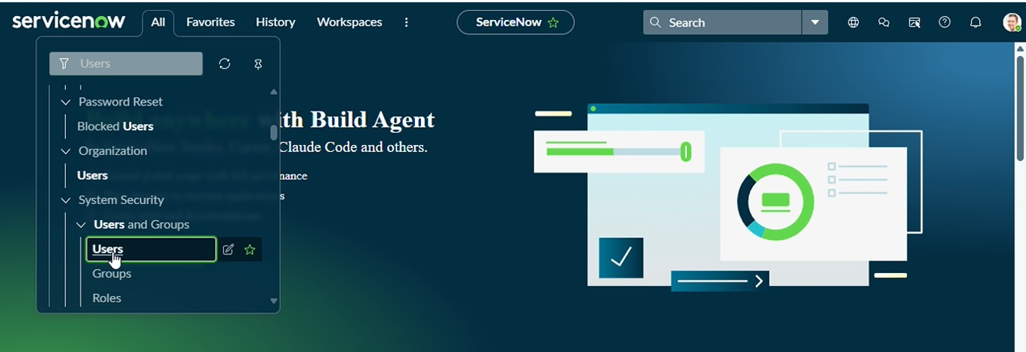
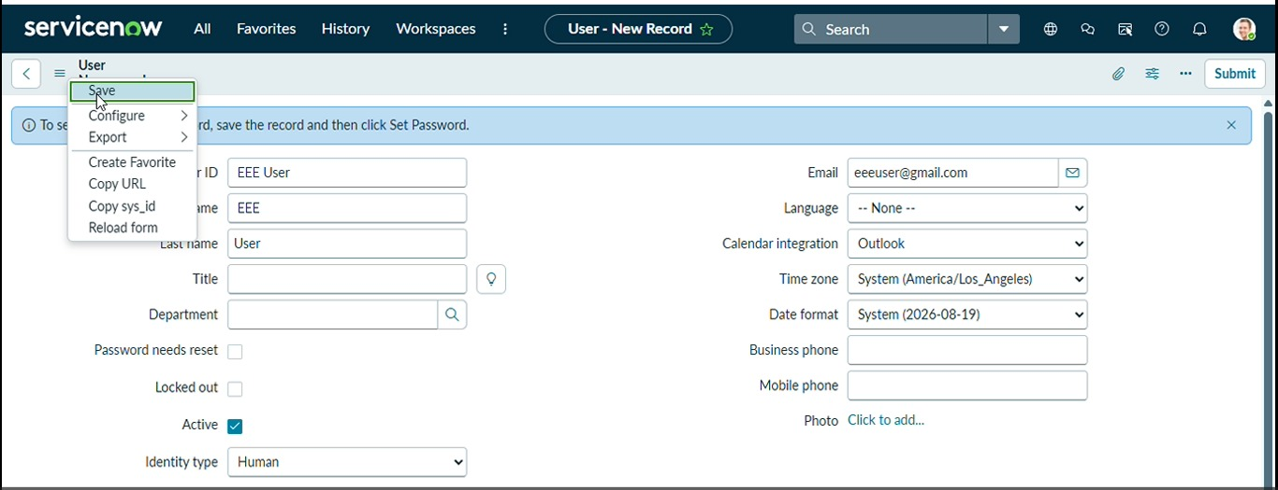
Role Creation
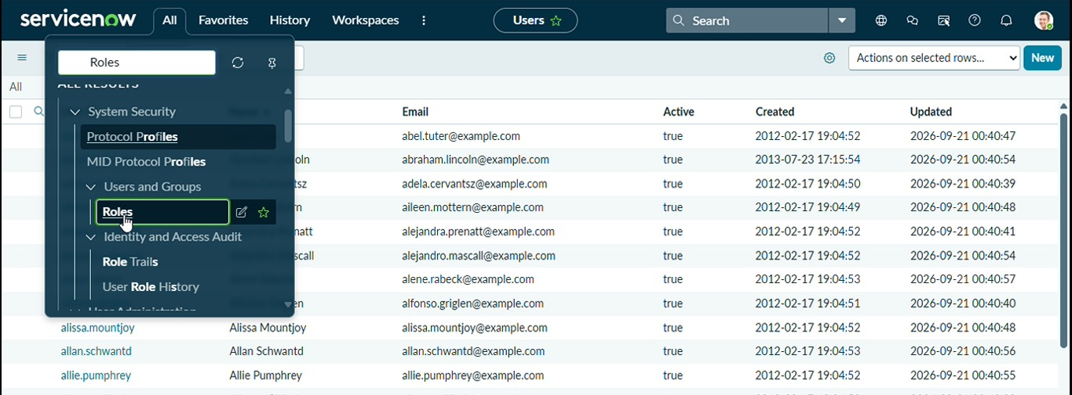
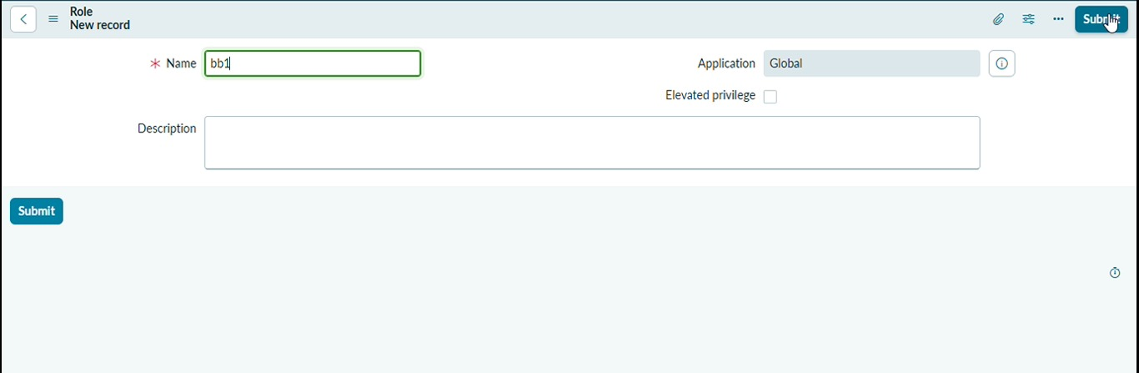
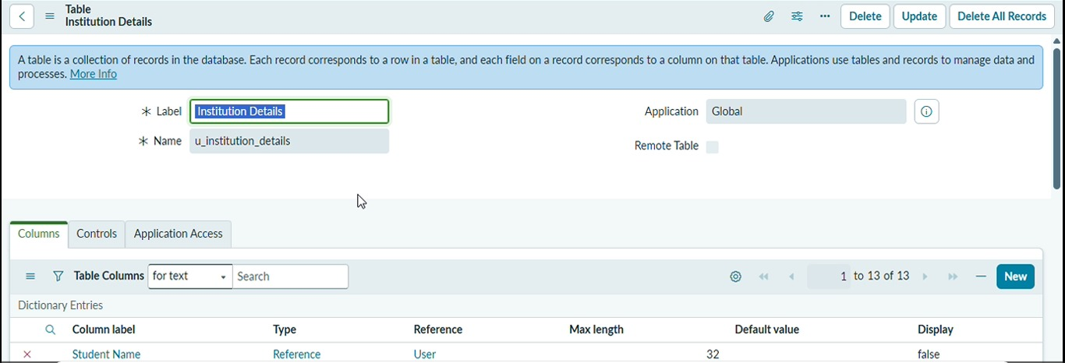
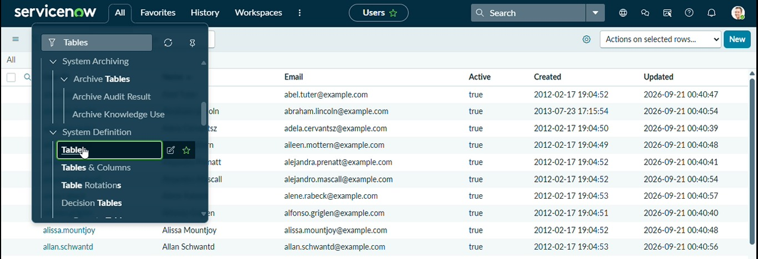
Tables Creation
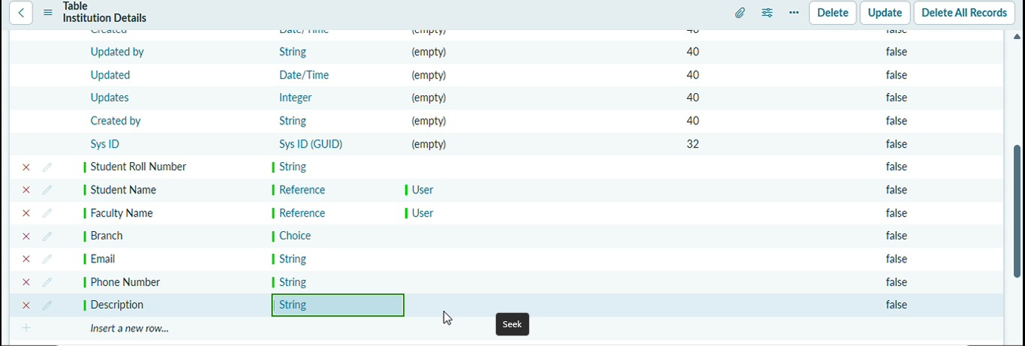
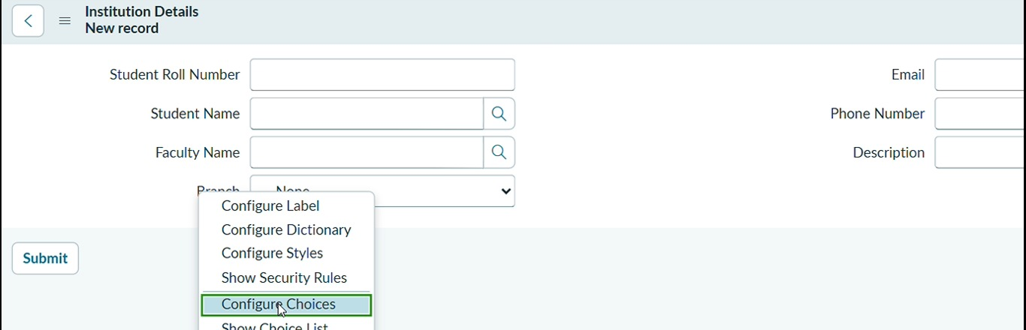
- Creation of Access Control Lists(Read ACL)
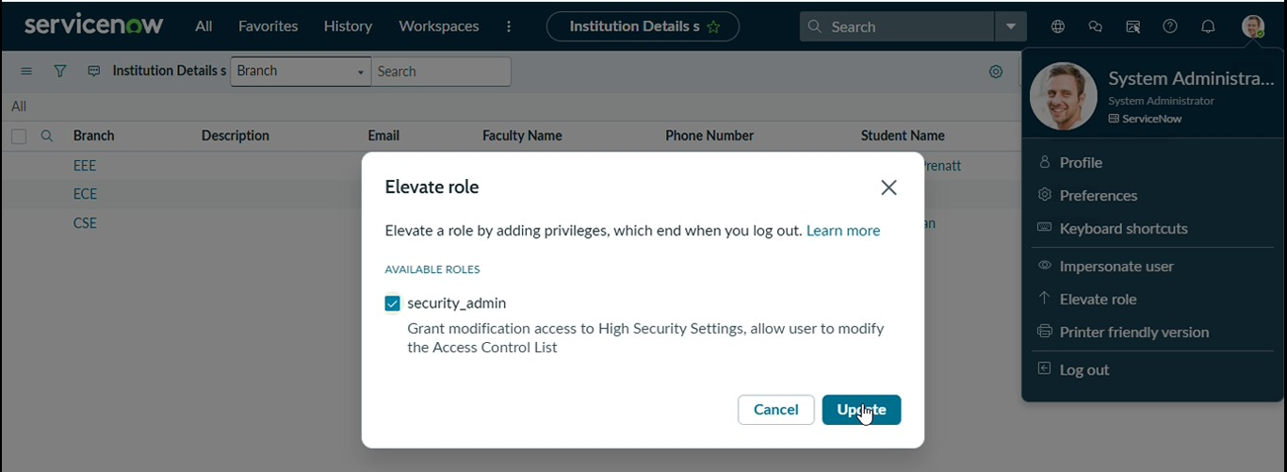
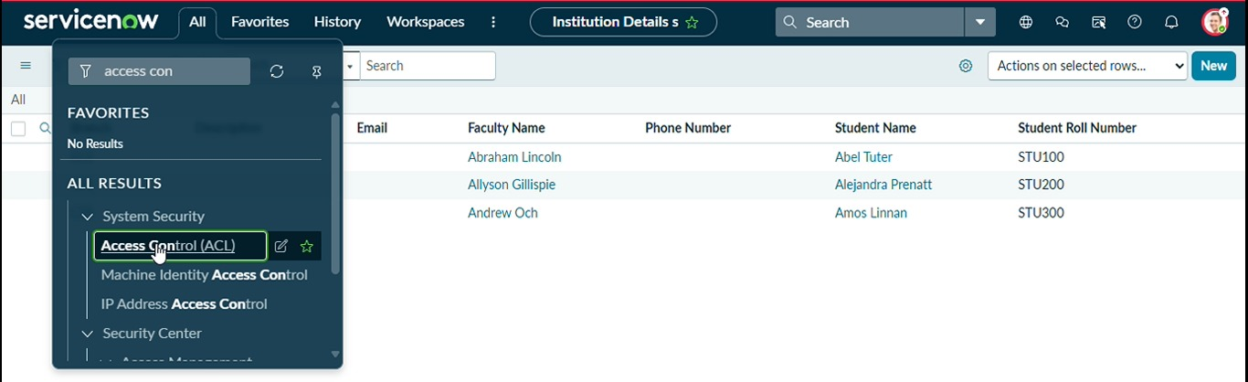
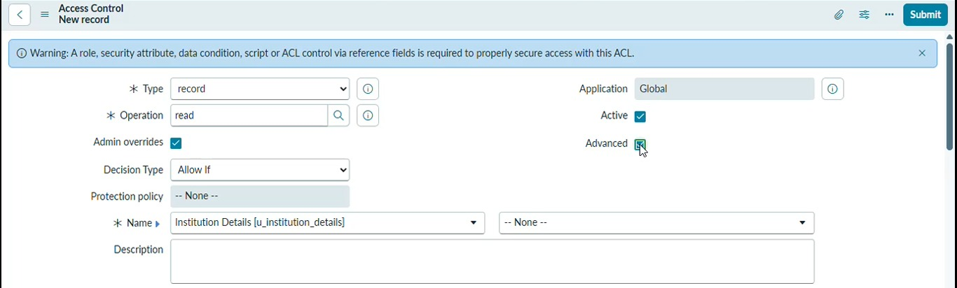
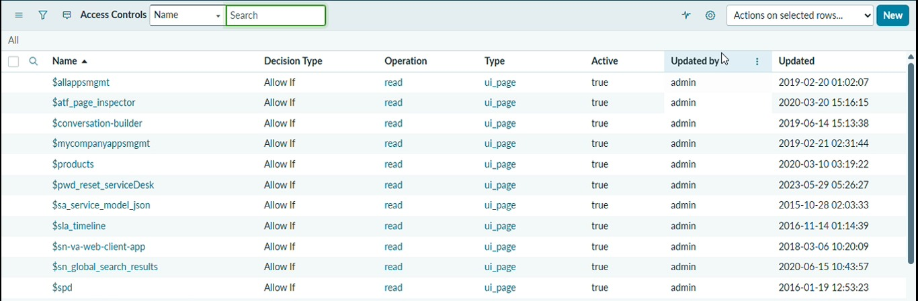
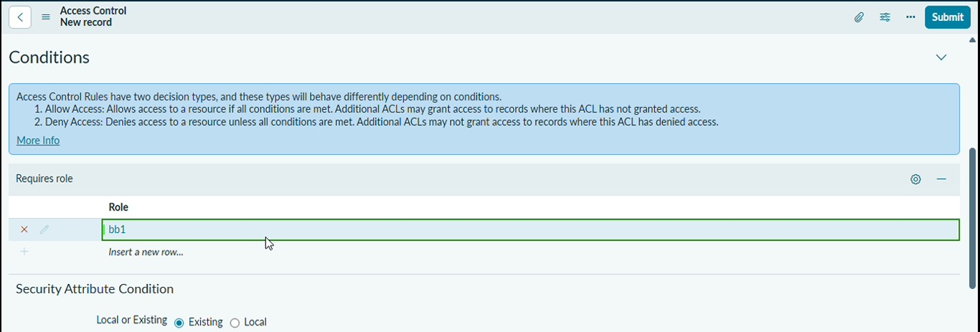
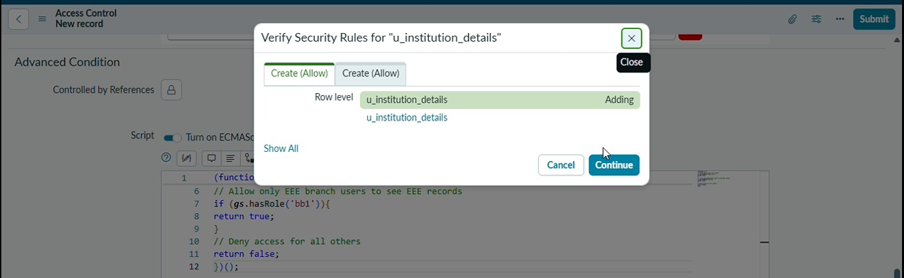
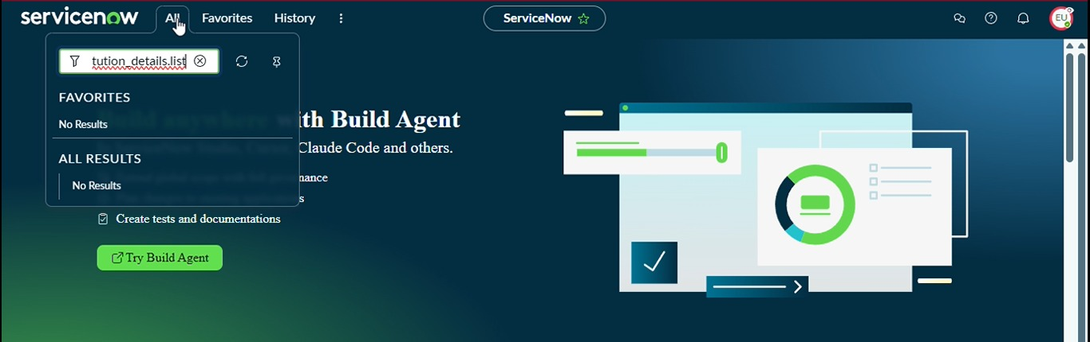
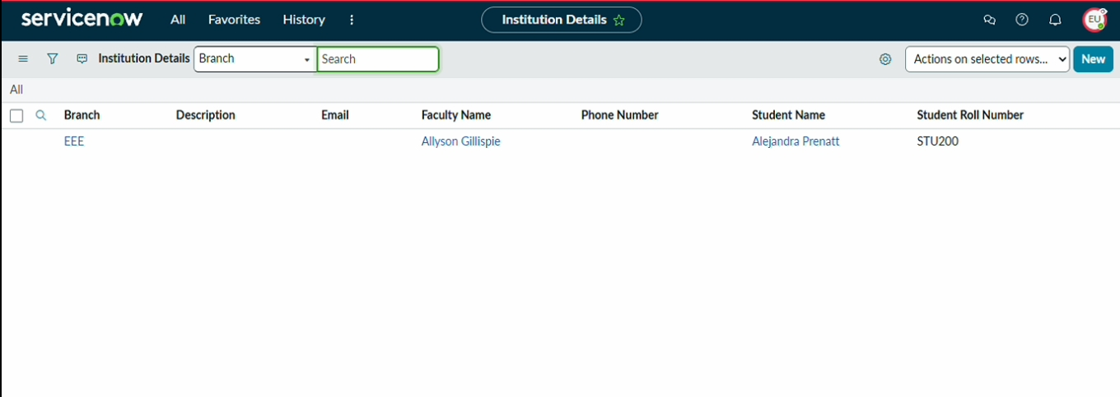
- Outcome

- Technologies Used
The following technologies and ServiceNow components are used in the project:
- ServiceNow
ServiceNow is the platform used to configure tables, records, users, and security rules.
- Access Control List (ACL)
ACLs are used to control access to ServiceNow resources such as records and fields.
- JavaScript
JavaScript is used to implement the custom logic required for checking the field value.
- ServiceNow User Information
User information is used by the script when the access decision depends on the current user’s details.

- ACL Configuration

The ACL is configured for the required table and operation.
Common ACL operations include:
Read – controls whether a user can view a record.
Write – controls whether a user can modify a record.
Create – controls whether a user can create a record.
Delete – controls whether a user can delete a record.
For this project, a Read ACL can be used when the requirement is to restrict users from viewing particular records.
The ACL contains the required conditions and script logic.

- Script Logic
The script is the main part of the project. It evaluates the required field value and determines whether access should be allowed.
A simplified example is:
If (current.u_department == gs.getUser().department) {
Answer = true;
} else {
Answer = false;
}
Explanation
Current refers to the record currently being accessed.
U_department represents the field that is being checked.
Gs.getUser() represents the current logged-in user.
Department represents the user’s department information.
Answer = true means access is allowed.
Answer = false means access is denied.
The actual field and comparison logic can be changed according to the project requirement.
- Access Decision Process

The access decision takes place when a user attempts to access a record.
Step 1 – User Requests Record
The user attempts to open or access a particular record.
Step 2 – ACL Evaluation
ServiceNow checks the applicable ACL rules for the requested operation.
Step 3 – Script Execution
If the ACL contains a script, the script evaluates the required condition.
Step 4 – Field Value Verification
The script checks the selected field value from the record.
Step 5 – Access Decision
Based on the result:
Condition Satisfied → Access Allowed
Condition Not Satisfied → Access Denied
This provides dynamic record-level security.

- Security Considerations

Security is the primary purpose of this project.
The Script-Controlled ACL helps protect records from unauthorized access. Instead of allowing every user who can reach the table to view all records, the ACL applies an additional security check.
The project can help to:
Protect confidential records.
Prevent unauthorized viewing.
Restrict department-specific information.
Reduce accidental exposure of data.
Provide more controlled access to records.
The ACL should be carefully designed and tested because an incorrect security script can unintentionally allow or prevent access.

- Project Result

After implementing and testing the ACL, the system can determine whether a user should be allowed to access a record based on the selected field value.
The project demonstrates that ServiceNow ACL scripting can be used to implement customized and dynamic record-level security.
The final result is:
Matching Condition → User Can Access the Record
Non-Matching Condition → User Cannot Access the Record

- Maintenance and Future Enhancement

The documentation should also explain how the project can be maintained in the future.
Possible enhancements include:
Adding multiple field-value checks.
Supporting different user groups.
Adding role-based conditions.
Applying similar logic to Write or Delete operations.
Improving error handling.
Adding more detailed testing scenarios.
Reusing the security logic for other tables where appropriate.
Any future modification should be tested carefully to ensure that existing security rules are not affected.

- Documentation Summary
The Project Documentation Phase records the complete implementation of the Script-Controlled ACL. It explains the project objective, problem statement, proposed solution, ACL configuration, scripting logic, access decision process, testing, security considerations, and final result.
Proper documentation makes the project easier to understand and maintain. It also provides a reference for administrators and developers who may need to modify or troubleshoot the ACL in the future.
- Conclusion
The Script-Controlled ACL provides a flexible approach to controlling access to ServiceNow records. By checking field values through server-side ACL logic, the system can make access decisions dynamically. This improves record-level security and helps ensure that users receive access only when the defined security conditions are satisfied.

